CURRICULUM VITAE

JAVVAJI VENKATARAO  MOBILE:9966368012  EMAIL: javvajivenkat6@gmail.com | 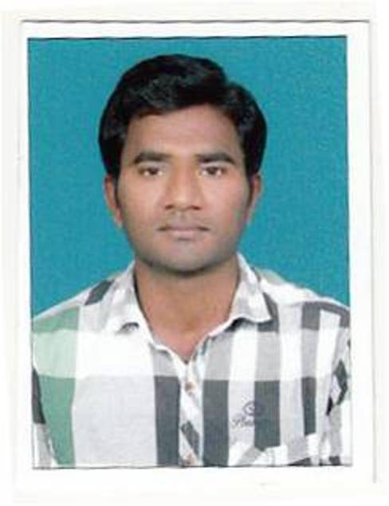
.

Objective:

I would like to work in a creative and challenging environment where there is scope for upgrading skills and knowledge and where I can take part in the growth of the organization.

Work Experience: 5 Months

- Working as Asst. Professor in the Dept of Computer Science & Engineering in Sri Indu Institute of Engineering and Technology, Sheriguda, Ranga Reddy dist from Feb 2015 to till date.

Educational Qualifications:

- Master of Technology (Computer Science and Engineering) in Aditya Engineering College,Kakinada with an aggregate of 67%. Affiliated to JNTUK in 2015.
- Bachelor of Technology in Computer science and Engineering from E V M . Engineering College,Narasaraopet with an aggregate of 61.12%. Affiliated to JNTUK in 2012.
- Inter From Krishnaveni Jr.College, Narasaraopet, Guntur 2008 with 62.9%.
- S.S.C. (Board of Secondary Education A.P) from ZPH School gudipadu, in 2006 with an aggregate of 61.5%.

Technical Skills:

Operating System : Windows 98/Xp, Linux,
Programming Languages : C, C++, SQL, My SQL, PL/SQL,.Net
Database : Big Data, MS Access.
Web Technologies : HTML, DHTML,

.

PERSONAL DETAILS

Name : J Venkatarao
Father's Name : J Ramarao
Mother's Name : Narasamma.
Date of Birth : 6th May 1991.
Sex : Male.
Traits : Good learner, Adaptability and Team Player.
Languages Known : English, Telugu.

Permanent Address: Present address :

H-No 1-416/A H.NO EWS 252
Tank Bazaar, BHARATH NAGAR
Gogulapadu(v), HYDERABAD.
Rompicherla(m), Guntur dist
AP, India 522 617.

Declaration:

I hereby declare that all the information furnished above is true to the best of my knowledge and belief.

Place: Hyderabad.
Date: (J Venkatarao)

